

Openflow protocol

Project Report



CSE:1004

NETWORK AND COMMUNICATION

PROF UMADEVI K S

15BCE0311

KANAV SETHI

kanav.sethi2015@vit.ac.in

**INTRODUCTION TO ARCHITECTURE**

OpenFlow is an open standard that enables researchers to run experimental protocols in the campus networks we use every day. OpenFlow is added as a feature to commercial Ethernet switches, routers and wireless access points – and provides a standardized hook to allow researchers to run experiments, without requiring providers to show the internal workings in their network devices. OpenFlow is presently being implemented by means of primary vendors, with OpenFlow-enabled switches now commercially available.

In a classical router or switch, the fast packet forwarding (data path) and the high-level routing decisions (control path) occur on the same device. An OpenFlow Switch separates these two functions. The data path portion still resides on the switch, while high-level routing decisions are moved to a separate controller, typically a standard server. The OpenFlow switch and Controller communicate thru the OpenFlow protocol, which defines messages, consisting of packet-acquired, ship-packet-out, adjust-forwarding-table, and get-stats.

The data path of an OpenFlow transfer provides a clean flow table abstraction; every flow table entry carries a set of packet fields to suit, and an action (which include ship-out-port, regulate-field, or drop). while an OpenFlow transfer gets a packet, it has by no means seen before, for which it has no matching flow entries, it sends this packet to the controller. The controller then makes a decision on how to handle this packet. It can drop the packet, or it can add a flow entry directing the switch on how to forward similar packets in the future.

OpenFlow allows you to easily deploy innovative routing and switching protocols in your network. It is used for applications such as virtual machine mobility, high-security networks and next generation ip based mobile networks.

**LITERATURE REVIEW**

Peter Dely et al. suggest several protocols for routing and forwarding in Wireless Mesh Networks (WMN). OpenFlow is an emerging technology which makes network elements such as routers or switches programmable via a standardized interface. through the usage of virtualization and flow-based routing, OpenFlow enables a fast deployment of novel packet forwarding and routing algorithms, specializing in fixed networks. They suggest a structure that integrates OpenFlow with WMNs and gives such flow-based routing and forwarding capabilities.

when constructing a network primarily based on OpenFlow however, one should bear in mind the overall performance characteristics of specific OpenFlow switch implementations. in their paper, Charalampos et al. show OFLOPS, an open and regular software program framework that allows the development of tests for OpenFlow-enabled switches, that measure the capabilities and bottlenecks between the forwarding engine of the switch and the remote-control application. OFLOPS combines hardware instrumentation with an extensible software program framework.

in their paper, Alexander et al. present an independent complete analysis of the performance indexes of famous open source SDN/OpenFlow controllers (NOX, POX, Beacon, Floodlight, MuL, Maestro, Ryu). The analyzed indexes include performance, scalability, reliability, and security. For testing purposes, we developed the new framework called hcprobe. The test bed and the methodology we used are discussed in detail so that everyone could reproduce our experiments. The result of the evaluation show that modern SDN/OpenFlow controllers are not ready to be used in production and have to be improved in order to increase all above mentioned characteristics.

**PROBLEM STATEMENT**

Mathematical model of cloud computing data center

based on OpenFlow.

A comparison between the different levels of traffic through a OpenFlow switch and tabulation of its statistics.

**PROBLEM SOLUTION**

Simulation done in NS3 using different number of nodes and measuring the data using Flow monitor and NetAnim.

**IMPLEMENTATION**

/* -*- Mode:C++; c-file-style:"gnu"; indent-tabs-mode:nil; -*- */

#include <iostream>

#include <fstream>

#include "ns3/core-module.h"

#include "ns3/network-module.h"

#include "ns3/csma-module.h"

#include "ns3/internet-module.h"

#include "ns3/applications-module.h"

#include "ns3/openflow-module.h"

#include "ns3/log.h"

#include "ns3/flow-monitor-module.h"

#include "ns3/netanim-module.h"

#include "ns3/mobility-helper.h"

using namespace ns3;

NS_LOG_COMPONENT_DEFINE ("OpenFlowCsmaSwitchExample");

bool verbose = false;

bool use_drop = false;

ns3::Time timeout = ns3::Seconds (0);

bool SetVerbose (std::string value)

{

verbose = true;

return true;

}

bool SetDrop (std::string value)

{

use_drop = true;

return true;

}

bool SetTimeout (std::string value)

{

try {

timeout = ns3::Seconds (atof (value.c_str ()));

return true;

}

catch (...) { return false; }

return false;

}

int main (int argc, char *argv[])

{

#ifdef NS3_OPENFLOW

//

// Allow the user to override any of the defaults and the above Bind() at

// run-time, via command-line arguments

//

CommandLine cmd;

cmd.AddValue ("v", "Verbose (turns on logging).", MakeCallback (&SetVerbose));

cmd.AddValue ("verbose", "Verbose (turns on logging).", MakeCallback (&SetVerbose));

cmd.AddValue ("d", "Use Drop Controller (Learning if not specified).", MakeCallback (&SetDrop));

cmd.AddValue ("drop", "Use Drop Controller (Learning if not specified).", MakeCallback(&SetDrop));

cmd.AddValue ("t", "Learning Controller Timeout (has no effect if drop controller is specified).", MakeCallback ( &SetTimeout));

cmd.AddValue ("timeout", "Learning Controller Timeout (has no effect if drop controller is specified).", MakeCallback ( &SetTimeout));

cmd.Parse (argc, argv);

if (verbose)

{

LogComponentEnable ("OpenFlowCsmaSwitchExample", LOG_LEVEL_INFO);

LogComponentEnable ("OpenFlowInterface", LOG_LEVEL_INFO);

LogComponentEnable ("OpenFlowSwitchNetDevice", LOG_LEVEL_INFO);

}

//

// Explicitly create the nodes required by the topology (shown above).

//

NS_LOG_INFO ("Create nodes.");

NodeContainer terminals;

terminals.Create (11);

NodeContainer csmaSwitch;

csmaSwitch.Create (1);

NS_LOG_INFO ("Build Topology");

CsmaHelper csma;

csma.SetChannelAttribute ("DataRate", DataRateValue (5000000));

csma.SetChannelAttribute ("Delay", TimeValue (MilliSeconds (2)));

// Create the csma links, from each terminal to the switch

NetDeviceContainer terminalDevices;

NetDeviceContainer switchDevices;

for (int i = 0; i < 11; i++)

{

NetDeviceContainer link = csma.Install (NodeContainer (terminals.Get (i), csmaSwitch));

terminalDevices.Add (link.Get (0));

switchDevices.Add (link.Get (1));

}

// Create the switch netdevice, which will do the packet switching

Ptr<Node> switchNode = csmaSwitch.Get (0);

OpenFlowSwitchHelper swtch;

if (use_drop)

{

Ptr<ns3::ofi::DropController> controller = CreateObject<ns3::ofi::DropController> ();

swtch.Install (switchNode, switchDevices, controller);

}

else

{

Ptr<ns3::ofi::LearningController> controller = CreateObject<ns3::ofi::LearningController> ();

if (!timeout.IsZero ()) controller->SetAttribute ("ExpirationTime", TimeValue (timeout));

swtch.Install (switchNode, switchDevices, controller);

}

// Add internet stack to the terminals

InternetStackHelper internet;

internet.Install (terminals);

// We've got the "hardware" in place. Now we need to add IP addresses.

NS_LOG_INFO ("Assign IP Addresses.");

Ipv4AddressHelper ipv4;

ipv4.SetBase ("10.1.1.0", "255.255.255.0");

ipv4.Assign (terminalDevices);

// Create an OnOff application to send UDP datagrams from n0 to n1.

NS_LOG_INFO ("Create Applications.");

uint16_t port = 9; // Discard port (RFC 863)

OnOffHelper onoff ("ns3::UdpSocketFactory",

Address (InetSocketAddress (Ipv4Address ("10.1.1.1"), port)));

onoff.SetConstantRate (DataRate ("500kb/s"));

ApplicationContainer app = onoff.Install (terminals.Get (1));

// Start the application

app.Start (Seconds (1.0));

app.Stop (Seconds (10.0));

// Create an optional packet sink to receive these packets

PacketSinkHelper sink ("ns3::UdpSocketFactory",

Address (InetSocketAddress (Ipv4Address::GetAny (), port)));

app = sink.Install (terminals.Get (0));

app.Start (Seconds (0.0));

//

// Create a similar flow from n3 to n0, starting at time 1.1 seconds

//

onoff.SetAttribute ("Remote",

AddressValue (InetSocketAddress (Ipv4Address ("10.1.1.2"), port)));

app = onoff.Install (terminals.Get (2));

app.Start (Seconds (1.0));

app.Stop (Seconds (10.0));

app = sink.Install (terminals.Get (0));

app.Start (Seconds (0.0));

//

// Create a similar flow from n3 to n0, starting at time 1.1 seconds

//

onoff.SetAttribute ("Remote",

AddressValue (InetSocketAddress (Ipv4Address ("10.1.1.3"), port)));

app = onoff.Install (terminals.Get (3));

app.Start (Seconds (1.0));

app.Stop (Seconds (10.0));

app = sink.Install (terminals.Get (0));

app.Start (Seconds (0.0));

//

// Create a similar flow from n3 to n0, starting at time 1.1 seconds

//

onoff.SetAttribute ("Remote",

AddressValue (InetSocketAddress (Ipv4Address ("10.1.1.4"), port)));

app = onoff.Install (terminals.Get (4));

app.Start (Seconds (1.0));

app.Stop (Seconds (10.0));

app = sink.Install (terminals.Get (0));

app.Start (Seconds (0.0));

//

// Create a similar flow from n3 to n0, starting at time 1.1 seconds

//

onoff.SetAttribute ("Remote",

AddressValue (InetSocketAddress (Ipv4Address ("10.1.1.5"), port)));

app = onoff.Install (terminals.Get (5));

app.Start (Seconds (1.0));

app.Stop (Seconds (10.0));

app = sink.Install (terminals.Get (0));

app.Start (Seconds (0.0));

//

// Create a similar flow from n3 to n0, starting at time 1.1 seconds

//

onoff.SetAttribute ("Remote",

AddressValue (InetSocketAddress (Ipv4Address ("10.1.1.6"), port)));

app = onoff.Install (terminals.Get (6));

app.Start (Seconds (1.0));

app.Stop (Seconds (10.0));

app = sink.Install (terminals.Get (0));

app.Start (Seconds (0.0));

//

// Create a similar flow from n3 to n0, starting at time 1.1 seconds

//

onoff.SetAttribute ("Remote",

AddressValue (InetSocketAddress (Ipv4Address ("10.1.1.7"), port)));

app = onoff.Install (terminals.Get (7));

app.Start (Seconds (1.0));

app.Stop (Seconds (10.0));

app = sink.Install (terminals.Get (0));

app.Start (Seconds (0.0));

//

// Create a similar flow from n3 to n0, starting at time 1.1 seconds

//

onoff.SetAttribute ("Remote",

AddressValue (InetSocketAddress (Ipv4Address ("10.1.1.8"), port)));

app = onoff.Install (terminals.Get (8));

app.Start (Seconds (1.0));

app.Stop (Seconds (10.0));

app = sink.Install (terminals.Get (0));

app.Start (Seconds (0.0));

//

// Create a similar flow from n3 to n0, starting at time 1.1 seconds

//

onoff.SetAttribute ("Remote",

AddressValue (InetSocketAddress (Ipv4Address ("10.1.1.9"), port)));

app = onoff.Install (terminals.Get (9));

app.Start (Seconds (1.0));

app.Stop (Seconds (10.0));

app = sink.Install (terminals.Get (0));

app.Start (Seconds (0.0));

//

// Create a similar flow from n3 to n0, starting at time 1.1 seconds

//

onoff.SetAttribute ("Remote",

AddressValue (InetSocketAddress (Ipv4Address ("10.1.1.10"), port)));

app = onoff.Install (terminals.Get (10));

app.Start (Seconds (1.0));

app.Stop (Seconds (10.0));

app = sink.Install (terminals.Get (0));

app.Start (Seconds (0.0));

NS_LOG_INFO ("FlowMonitor.");

FlowMonitorHelper flowmon;

Ptr<FlowMonitor> monitor = flowmon.InstallAll();

//

// Now, do the actual simulation.

//

MobilityHelper mobility;

// setup the grid itself: objects are layed out

// started from (-100,-100) with 20 objects per row,

// the x interval between each object is 5 meters

// and the y interval between each object is 20 meters

mobility.SetPositionAllocator ("ns3::GridPositionAllocator",

"MinX", DoubleValue(10.0),

"MinY", DoubleValue(10.0),

"DeltaX", DoubleValue(5.0),

"DeltaY", DoubleValue(20.0),

"GridWidth", UintegerValue(20),

"LayoutType", StringValue("RowFirst"));

mobility.[SetMobilityModel](https://www.nsnam.org/doxygen/classns3_1_1_mobility_helper.html#a030275011b6f40682e70534d30280aba) ("ns3::ConstantPositionMobilityModel");

mobility.[Install](https://www.nsnam.org/doxygen/classns3_1_1_mobility_helper.html#a07737960ee95c0777109cf2994dd97ae) (terminals);

NS_LOG_INFO ("Run Simulation.");

Simulator::Stop (Seconds(11.0));

AnimationInterface anim ("animation10to1.xml");

Simulator::Run ();

monitor->CheckForLostPackets ();

Ptr<Ipv4FlowClassifier> classifier = DynamicCast<Ipv4FlowClassifier> (flowmon.GetClassifier ());

std::map<FlowId, FlowMonitor::FlowStats> stats = monitor->GetFlowStats ();

for (std::map<FlowId, FlowMonitor::FlowStats>::const_iterator i = stats.begin (); i != stats.end (); ++i)

{

Ipv4FlowClassifier::FiveTuple t = classifier->FindFlow (i->first);

std::cout << "Flow " << i->first << " (" << t.sourceAddress << " -> " << t.destinationAddress << ")\n";

std::cout << " Tx Packets = " << i->second.txPackets<< "\n";

std::cout << " Rx Packets = " << i->second.rxPackets<< "\n";

std::cout << " Tx Bytes: " << i->second.txBytes << "\n";

std::cout << " Rx Bytes: " << i->second.rxBytes << "\n";

std::cout << " Throughput: " << i->second.rxBytes * 8.0 / (i->second.timeLastRxPacket.GetSeconds() - i->second.timeFirstTxPacket.GetSeconds())/1024/1024 << " Mbps\n";

 std::cout << "  Lost Packets= " << i->second.lostPackets << "\n";

 std::cout << "  Delay Sum= " << i->second.delaySum << " \n";

std::cout << "  Jitter Sum= " << i->second.jitterSum << " \n";

}

monitor->SerializeToXmlFile("openflow10to1.flowmon", true, true);

Simulator::Destroy ();

NS_LOG_INFO ("Done.");

#else

NS_LOG_INFO ("NS-3 OpenFlow is not enabled. Cannot run simulation.");

#endif // NS3_OPENFLOW }

**PERFORMANCE METRICS**

**1 to 1 Flow**

Flow 1 (10.1.1.1 -> 10.1.1.2)

Tx Packets = 1098

Rx Packets = 1098

Tx Bytes: 592920

Rx Bytes: 592920

Throughput: 0.503049 Mbps

Lost Packets= 0

Delay Sum= +6380519708.0ns

Jitter Sum= +14411656.0ns

**2 to 1 Flow**

Flow 1 (10.1.1.2 -> 10.1.1.1)

Tx Packets = 1098

Rx Packets = 776

Tx Bytes: 592920

Rx Bytes: 419040

Throughput: 0.344607 Mbps

Lost Packets= 476

Delay Sum= +238570801832.0ns

Jitter Sum= +2865582116.0ns

Flow 2 (10.1.1.3 -> 10.1.1.2)

Tx Packets = 1098

Rx Packets = 1098

Tx Bytes: 592920

Rx Bytes: 592920

Throughput: 0.502615 Mbps

Lost Packets= 0

Delay Sum= +12405258518.0ns

Jitter Sum= +3764062656.0ns

**3 to 1 Flow**

Flow 1 (10.1.1.2 -> 10.1.1.1)

Tx Packets = 1098

Rx Packets = 1098

Tx Bytes: 592920

Rx Bytes: 592920

Throughput: 0.502889 Mbps

Lost Packets= 0

Delay Sum= +13844230523.0ns

Jitter Sum= +2546267918.0ns

Flow 2 (10.1.1.3 -> 10.1.1.2)

Tx Packets = 1098

Rx Packets = 651

Tx Bytes: 592920

Rx Bytes: 351540

Throughput: 0.268612 Mbps

Lost Packets= 739

Delay Sum= +410021717446.0ns

Jitter Sum= +3359803915.0ns

Flow 3 (10.1.1.4 -> 10.1.1.3)

Tx Packets = 1098

Rx Packets = 937

Tx Bytes: 592920

Rx Bytes: 505980

Throughput: 0.405292 Mbps

Lost Packets= 0

Delay Sum= +448560171134.0ns

Jitter Sum= +4874948933.0ns

**4 to 1 Flow**

Flow 1 (10.1.1.2 -> 10.1.1.1)

Tx Packets = 1098

Rx Packets = 1097

Tx Bytes: 592920

Rx Bytes: 592380

Throughput: 0.502583 Mbps

Lost Packets= 0

Delay Sum= +25756824776.0ns

Jitter Sum= +2829091720.0ns

Flow 2 (10.1.1.3 -> 10.1.1.2)

Tx Packets = 1098

Rx Packets = 736

Tx Bytes: 592920

Rx Bytes: 397440

Throughput: 0.304404 Mbps

Lost Packets= 579

Delay Sum= +365916275454.0ns

Jitter Sum= +3882889816.0ns

Flow 3 (10.1.1.4 -> 10.1.1.3)

Tx Packets = 1098

Rx Packets = 470

Tx Bytes: 592920

Rx Bytes: 253800

Throughput: 0.193976 Mbps

Lost Packets= 900

Delay Sum= +507763990507.0ns

Jitter Sum= +3746590149.0ns

Flow 4 (10.1.1.5 -> 10.1.1.4)

Tx Packets = 1098

Rx Packets = 1058

Tx Bytes: 592920

Rx Bytes: 571320

Throughput: 0.457493 Mbps

Lost Packets= 0

Delay Sum= +404794260297.0ns

Jitter Sum= +4765853519.0ns

**5 to 1 Flow**

Flow 1 (10.1.1.2 -> 10.1.1.1)

Tx Packets = 1098

Rx Packets = 1098

Tx Bytes: 592920

Rx Bytes: 592920

Throughput: 0.502693 Mbps

Lost Packets= 0

Delay Sum= +18935360664.0ns

Jitter Sum= +2508633716.0ns

Flow 2 (10.1.1.3 -> 10.1.1.2)

Tx Packets = 1098

Rx Packets = 656

Tx Bytes: 592920

Rx Bytes: 354240

Throughput: 0.270872 Mbps

Lost Packets= 703

Delay Sum= +403714317657.0ns

Jitter Sum= +3558098083.0ns

Flow 3 (10.1.1.4 -> 10.1.1.3)

Tx Packets = 1098

Rx Packets = 673

Tx Bytes: 592920

Rx Bytes: 363420

Throughput: 0.27789 Mbps

Lost Packets= 653

Delay Sum= +587210847604.0ns

Jitter Sum= +4200695103.0ns

Flow 4 (10.1.1.5 -> 10.1.1.4)

Tx Packets = 1098

Rx Packets = 527

Tx Bytes: 592920

Rx Bytes: 284580

Throughput: 0.217853 Mbps

Lost Packets= 919

Delay Sum= +446708827261.0ns

Jitter Sum= +3788768702.0ns

Flow 5 (10.1.1.6 -> 10.1.1.5)

Tx Packets = 1098

Rx Packets = 1028

Tx Bytes: 592920

Rx Bytes: 555120

Throughput: 0.442214 Mbps

Lost Packets= 0

Delay Sum= +449288919354.0ns

Jitter Sum= +4783205174.0ns

**6 to 1 Flow**

Flow 1 (10.1.1.2 -> 10.1.1.1)

Tx Packets = 1098

Rx Packets = 1098

Tx Bytes: 592920

Rx Bytes: 592920

Throughput: 0.503049 Mbps

Lost Packets= 0

Delay Sum= +26065090015.0ns

Jitter Sum= +2816081844.0ns

Flow 2 (10.1.1.3 -> 10.1.1.2)

Tx Packets = 1098

Rx Packets = 650

Tx Bytes: 592920

Rx Bytes: 351000

Throughput: 0.268202 Mbps

Lost Packets= 763

Delay Sum= +355995217747.0ns

Jitter Sum= +3535891592.0ns

Flow 3 (10.1.1.4 -> 10.1.1.3)

Tx Packets = 1098

Rx Packets = 572

Tx Bytes: 592920

Rx Bytes: 308880

Throughput: 0.236015 Mbps

Lost Packets= 776

Delay Sum= +534875833220.0ns

Jitter Sum= +3866428945.0ns

Flow 4 (10.1.1.5 -> 10.1.1.4)

Tx Packets = 1098

Rx Packets = 615

Tx Bytes: 592920

Rx Bytes: 332100

Throughput: 0.253656 Mbps

Lost Packets= 775

Delay Sum= +452193327926.0ns

Jitter Sum= +3900067767.0ns

Flow 5 (10.1.1.6 -> 10.1.1.5)

Tx Packets = 1098

Rx Packets = 607

Tx Bytes: 592920

Rx Bytes: 327780

Throughput: 0.250741 Mbps

Lost Packets= 733

Delay Sum= +458094227664.0ns

Jitter Sum= +3783611786.0ns

Flow 6 (10.1.1.7 -> 10.1.1.6)

Tx Packets = 1098

Rx Packets = 1025

Tx Bytes: 592920

Rx Bytes: 553500

Throughput: 0.446206 Mbps

Lost Packets= 0

Delay Sum= +450051847476.0ns

Jitter Sum= +4862753543.0ns

**7 to 1 Flow**

Flow 1 (10.1.1.2 -> 10.1.1.1)

Tx Packets = 1098

Rx Packets = 1097

Tx Bytes: 592920

Rx Bytes: 592380

Throughput: 0.499802 Mbps

Lost Packets= 0

Delay Sum= +37047917872.0ns

Jitter Sum= +3340983054.0ns

Flow 2 (10.1.1.3 -> 10.1.1.2)

Tx Packets = 1098

Rx Packets = 713

Tx Bytes: 592920

Rx Bytes: 385020

Throughput: 0.294976 Mbps

Lost Packets= 668

Delay Sum= +348738171085.0ns

Jitter Sum= +3693947669.0ns

Flow 3 (10.1.1.4 -> 10.1.1.3)

Tx Packets = 1098

Rx Packets = 523

Tx Bytes: 592920

Rx Bytes: 282420

Throughput: 0.215894 Mbps

Lost Packets= 857

Delay Sum= +464918191008.0ns

Jitter Sum= +4211789637.0ns

Flow 4 (10.1.1.5 -> 10.1.1.4)

Tx Packets = 1098

Rx Packets = 597

Tx Bytes: 592920

Rx Bytes: 322380

Throughput: 0.246449 Mbps

Lost Packets= 818

Delay Sum= +435765157296.0ns

Jitter Sum= +3805109176.0ns

Flow 5 (10.1.1.6 -> 10.1.1.5)

Tx Packets = 1098

Rx Packets = 631

Tx Bytes: 592920

Rx Bytes: 340740

Throughput: 0.260254 Mbps

Lost Packets= 757

Delay Sum= +442064637025.0ns

Jitter Sum= +4011868871.0ns

Flow 6 (10.1.1.7 -> 10.1.1.6)

Tx Packets = 1098

Rx Packets = 510

Tx Bytes: 592920

Rx Bytes: 275400

Throughput: 0.210331 Mbps

Lost Packets= 885

Delay Sum= +442012959000.0ns

Jitter Sum= +3760380024.0ns

Flow 7 (10.1.1.8 -> 10.1.1.7)

Tx Packets = 1098

Rx Packets = 1059

Tx Bytes: 592920

Rx Bytes: 571860

Throughput: 0.460131 Mbps

Lost Packets= 0

Delay Sum= +441750839189.0ns

Jitter Sum= +4660638176.0ns

**8 to 1 Flow**

Flow 1 (10.1.1.2 -> 10.1.1.1)

Tx Packets = 1098

Rx Packets = 1097

Tx Bytes: 592920

Rx Bytes: 592380

Throughput: 0.50132 Mbps

Lost Packets= 0

Delay Sum= +38243228150.0ns

Jitter Sum= +3360622130.0ns

Flow 2 (10.1.1.3 -> 10.1.1.2)

Tx Packets = 1098

Rx Packets = 732

Tx Bytes: 592920

Rx Bytes: 395280

Throughput: 0.30288 Mbps

Lost Packets= 630

Delay Sum= +295398850895.0ns

Jitter Sum= +3825427746.0ns

Flow 3 (10.1.1.4 -> 10.1.1.3)

Tx Packets = 1098

Rx Packets = 480

Tx Bytes: 592920

Rx Bytes: 259200

Throughput: 0.198145 Mbps

Lost Packets= 904

Delay Sum= +519256515244.0ns

Jitter Sum= +3871508393.0ns

Flow 4 (10.1.1.5 -> 10.1.1.4)

Tx Packets = 1098

Rx Packets = 636

Tx Bytes: 592920

Rx Bytes: 343440

Throughput: 0.262315 Mbps

Lost Packets= 782

Delay Sum= +347746638030.0ns

Jitter Sum= +3806836347.0ns

Flow 5 (10.1.1.6 -> 10.1.1.5)

Tx Packets = 1098

Rx Packets = 513

Tx Bytes: 592920

Rx Bytes: 277020

Throughput: 0.212374 Mbps

Lost Packets= 904

Delay Sum= +467825111520.0ns

Jitter Sum= +3751402497.0ns

Flow 6 (10.1.1.7 -> 10.1.1.6)

Tx Packets = 1098

Rx Packets = 706

Tx Bytes: 592920

Rx Bytes: 381240

Throughput: 0.291309 Mbps

Lost Packets= 658

Delay Sum= +439222460475.0ns

Jitter Sum= +4032929298.0ns

Flow 7 (10.1.1.8 -> 10.1.1.7)

Tx Packets = 1098

Rx Packets = 468

Tx Bytes: 592920

Rx Bytes: 252720

Throughput: 0.193042 Mbps

Lost Packets= 898

Delay Sum= +468563181336.0ns

Jitter Sum= +3767598210.0ns

Flow 8 (10.1.1.9 -> 10.1.1.8)

Tx Packets = 1098

Rx Packets = 1074

Tx Bytes: 592920

Rx Bytes: 579960

Throughput: 0.465729 Mbps

Lost Packets= 0

Delay Sum= +415175622092.0ns

Jitter Sum= +4545551777.0ns

**9 to 1 Flow**

Flow 1 (10.1.1.2 -> 10.1.1.1)

Tx Packets = 1098

Rx Packets = 1097

Tx Bytes: 592920

Rx Bytes: 592380

Throughput: 0.493751 Mbps

Lost Packets= 0

Delay Sum= +50548737621.0ns

Jitter Sum= +3281351143.0ns

Flow 2 (10.1.1.3 -> 10.1.1.2)

Tx Packets = 1098

Rx Packets = 668

Tx Bytes: 592920

Rx Bytes: 360720

Throughput: 0.276359 Mbps

Lost Packets= 726

Delay Sum= +351328602565.0ns

Jitter Sum= +3539363691.0ns

Flow 3 (10.1.1.4 -> 10.1.1.3)

Tx Packets = 1098

Rx Packets = 528

Tx Bytes: 592920

Rx Bytes: 285120

Throughput: 0.217797 Mbps

Lost Packets= 843

Delay Sum= +487501680425.0ns

Jitter Sum= +3876169089.0ns

Flow 4 (10.1.1.5 -> 10.1.1.4)

Tx Packets = 1098

Rx Packets = 587

Tx Bytes: 592920

Rx Bytes: 316980

Throughput: 0.242115 Mbps

Lost Packets= 794

Delay Sum= +406175767059.0ns

Jitter Sum= +3930072929.0ns

Flow 5 (10.1.1.6 -> 10.1.1.5)

Tx Packets = 1098

Rx Packets = 716

Tx Bytes: 592920

Rx Bytes: 386640

Throughput: 0.295367 Mbps

Lost Packets= 630

Delay Sum= +505890639651.0ns

Jitter Sum= +4193500954.0ns

Flow 6 (10.1.1.7 -> 10.1.1.6)

Tx Packets = 1098

Rx Packets = 485

Tx Bytes: 592920

Rx Bytes: 261900

Throughput: 0.200084 Mbps

Lost Packets= 970

Delay Sum= +467315440443.0ns

Jitter Sum= +3583335148.0ns

Flow 7 (10.1.1.8 -> 10.1.1.7)

Tx Packets = 1098

Rx Packets = 774

Tx Bytes: 592920

Rx Bytes: 417960

Throughput: 0.319949 Mbps

Lost Packets= 503

Delay Sum= +440551416940.0ns

Jitter Sum= +4518931987.0ns

Flow 8 (10.1.1.9 -> 10.1.1.8)

Tx Packets = 1098

Rx Packets = 449

Tx Bytes: 592920

Rx Bytes: 242460

Throughput: 0.185189 Mbps

Lost Packets= 982

Delay Sum= +527527446347.0ns

Jitter Sum= +3918520499.0ns

Flow 9 (10.1.1.10 -> 10.1.1.9)

Tx Packets = 1098

Rx Packets = 1064

Tx Bytes: 592920

Rx Bytes: 574560

Throughput: 0.461009 Mbps

Lost Packets= 0

Delay Sum= +323532284081.0ns

Jitter Sum= +4604235021.0ns

**10 to 1 Flow**

Flow 1 (10.1.1.2 -> 10.1.1.1)

Tx Packets = 1098

Rx Packets = 1097

Tx Bytes: 592920

Rx Bytes: 592380

Throughput: 0.502287 Mbps

Lost Packets= 0

Delay Sum= +23269679913.0ns

Jitter Sum= +3141757881.0ns

Flow 2 (10.1.1.3 -> 10.1.1.2)

Tx Packets = 1098

Rx Packets = 706

Tx Bytes: 592920

Rx Bytes: 381240

Throughput: 0.291162 Mbps

Lost Packets= 649

Delay Sum= +344022870224.0ns

Jitter Sum= +3995854027.0ns

Flow 3 (10.1.1.4 -> 10.1.1.3)

Tx Packets = 1098

Rx Packets = 503

Tx Bytes: 592920

Rx Bytes: 271620

Throughput: 0.207843 Mbps

Lost Packets= 869

Delay Sum= +556807430338.0ns

Jitter Sum= +4020267026.0ns

Flow 4 (10.1.1.5 -> 10.1.1.4)

Tx Packets = 1098

Rx Packets = 716

Tx Bytes: 592920

Rx Bytes: 386640

Throughput: 0.295334 Mbps

Lost Packets= 638

Delay Sum= +369703409050.0ns

Jitter Sum= +3990123925.0ns

Flow 5 (10.1.1.6 -> 10.1.1.5)

Tx Packets = 1098

Rx Packets = 501

Tx Bytes: 592920

Rx Bytes: 270540

Throughput: 0.206881 Mbps

Lost Packets= 932

Delay Sum= +460773349921.0ns

Jitter Sum= +3604628288.0ns

Flow 6 (10.1.1.7 -> 10.1.1.6)

Tx Packets = 1098

Rx Packets = 654

Tx Bytes: 592920

Rx Bytes: 353160

Throughput: 0.26977 Mbps

Lost Packets= 708

Delay Sum= +395325356669.0ns

Jitter Sum= +3828831178.0ns

Flow 7 (10.1.1.8 -> 10.1.1.7)

Tx Packets = 1098

Rx Packets = 565

Tx Bytes: 592920

Rx Bytes: 305100

Throughput: 0.232979 Mbps

Lost Packets= 857

Delay Sum= +472706219596.0ns

Jitter Sum= +3823531820.0ns

Flow 8 (10.1.1.9 -> 10.1.1.8)

Tx Packets = 1098

Rx Packets = 659

Tx Bytes: 592920

Rx Bytes: 355860

Throughput: 0.272111 Mbps

Lost Packets= 721

Delay Sum= +420731594995.0ns

Jitter Sum= +3948072359.0ns

Flow 9 (10.1.1.10 -> 10.1.1.9)

Tx Packets = 1098

Rx Packets = 553

Tx Bytes: 592920

Rx Bytes: 298620

Throughput: 0.228312 Mbps

Lost Packets= 824

Delay Sum= +502757251384.0ns

Jitter Sum= +3896236368.0ns

Flow 10 (10.1.1.11 -> 10.1.1.10)

Tx Packets = 1098

Rx Packets = 1036

Tx Bytes: 592920

Rx Bytes: 559440

Throughput: 0.446024 Mbps

Lost Packets= 0

Delay Sum= +457193705858.0ns

Jitter Sum= +4956752333.0ns

**PERFORMANCE ANALYSIS**

**1 to 1 Flow**

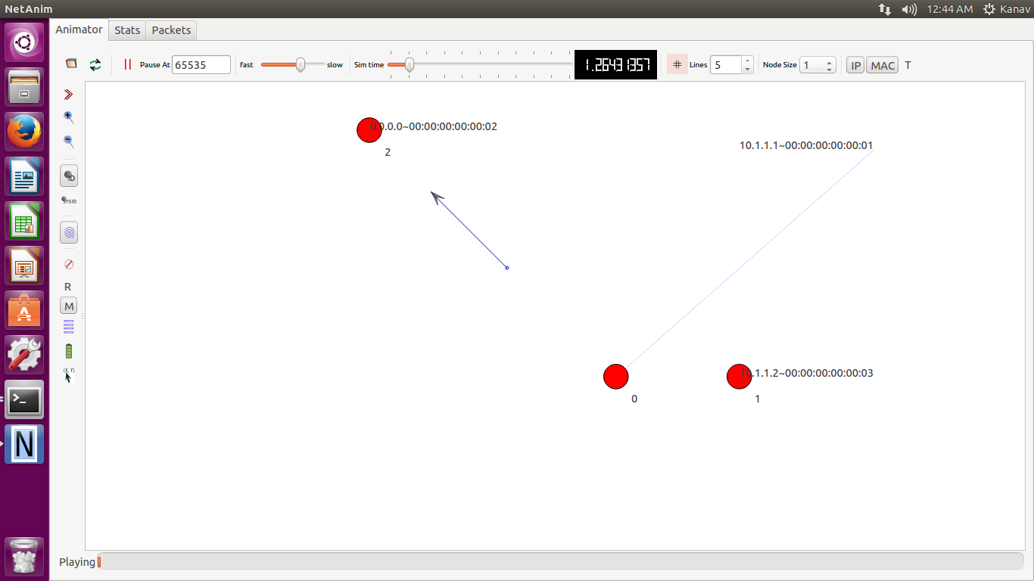

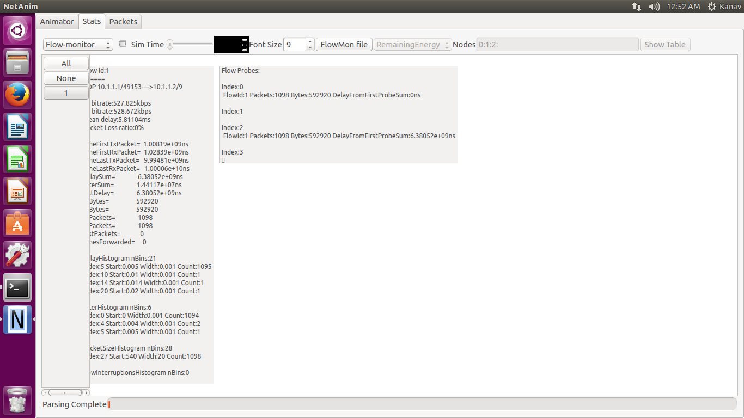

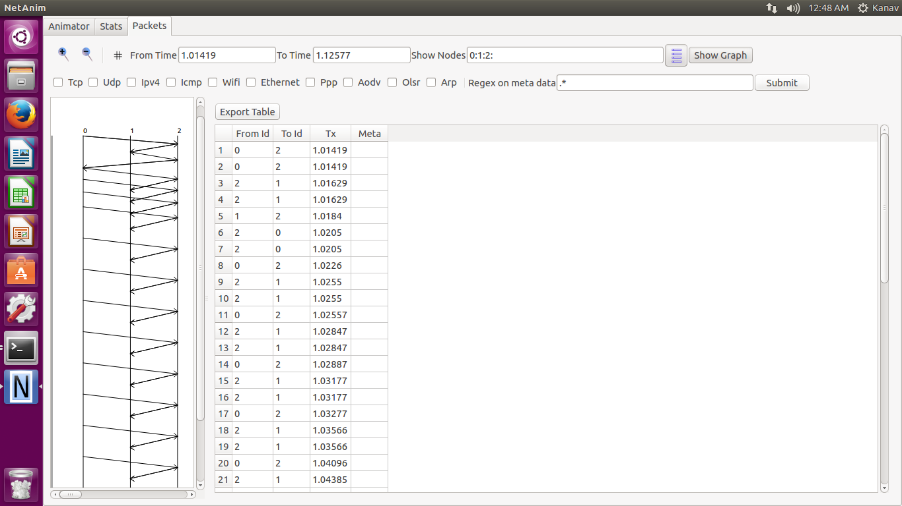

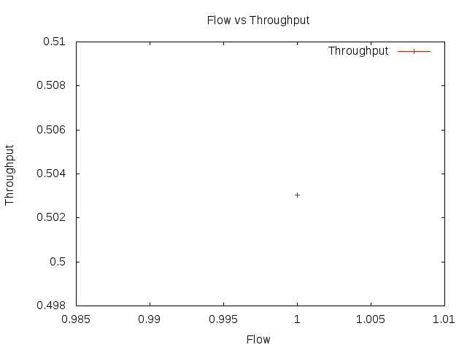

**2 to 1 Flow**

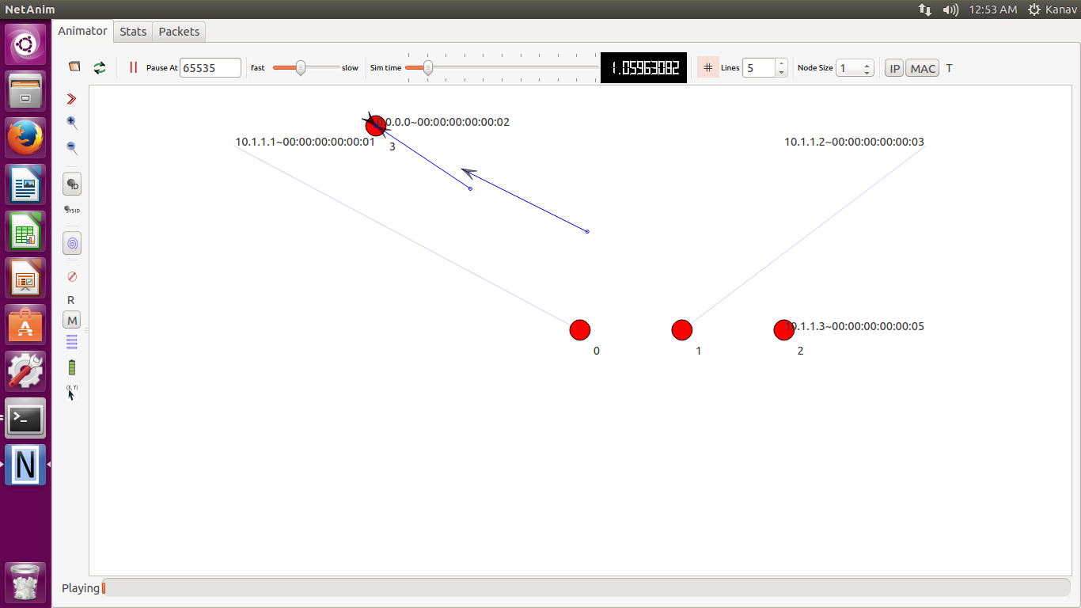

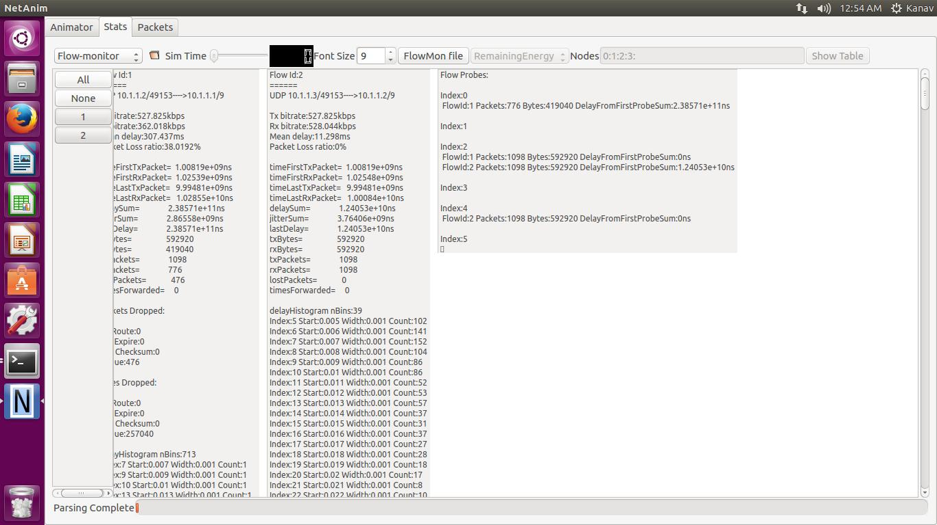

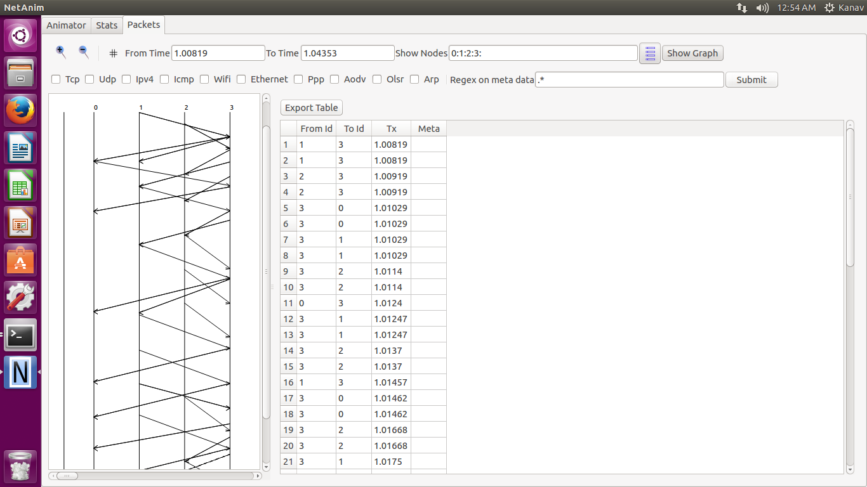

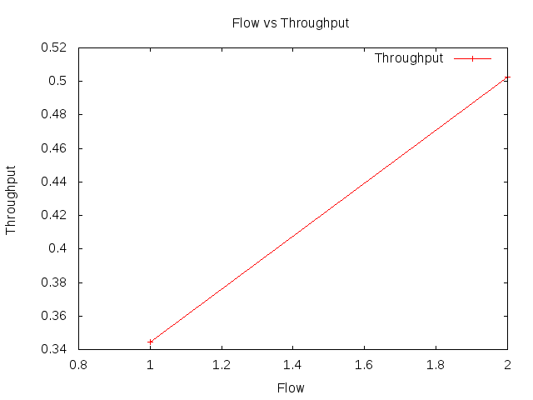

**3 to 1 Flow**

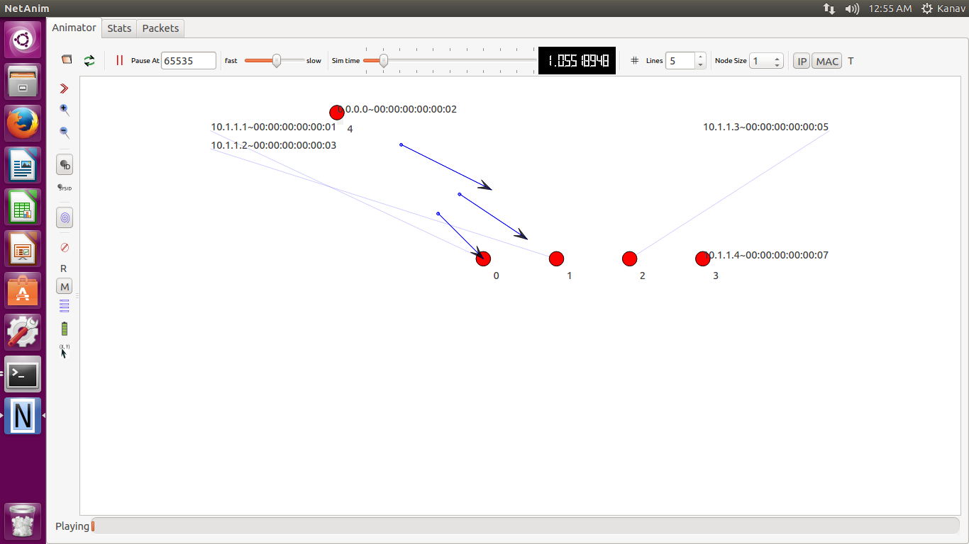

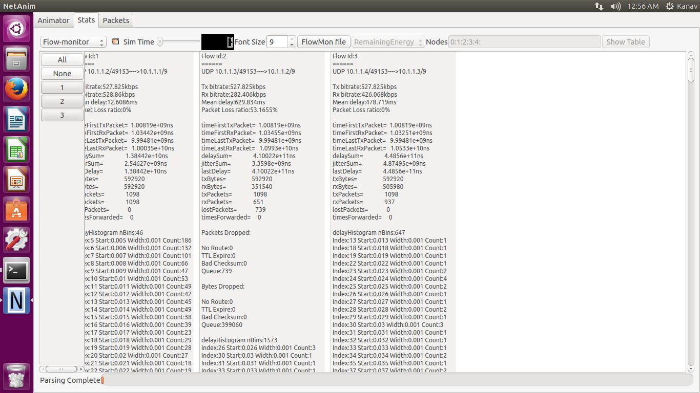

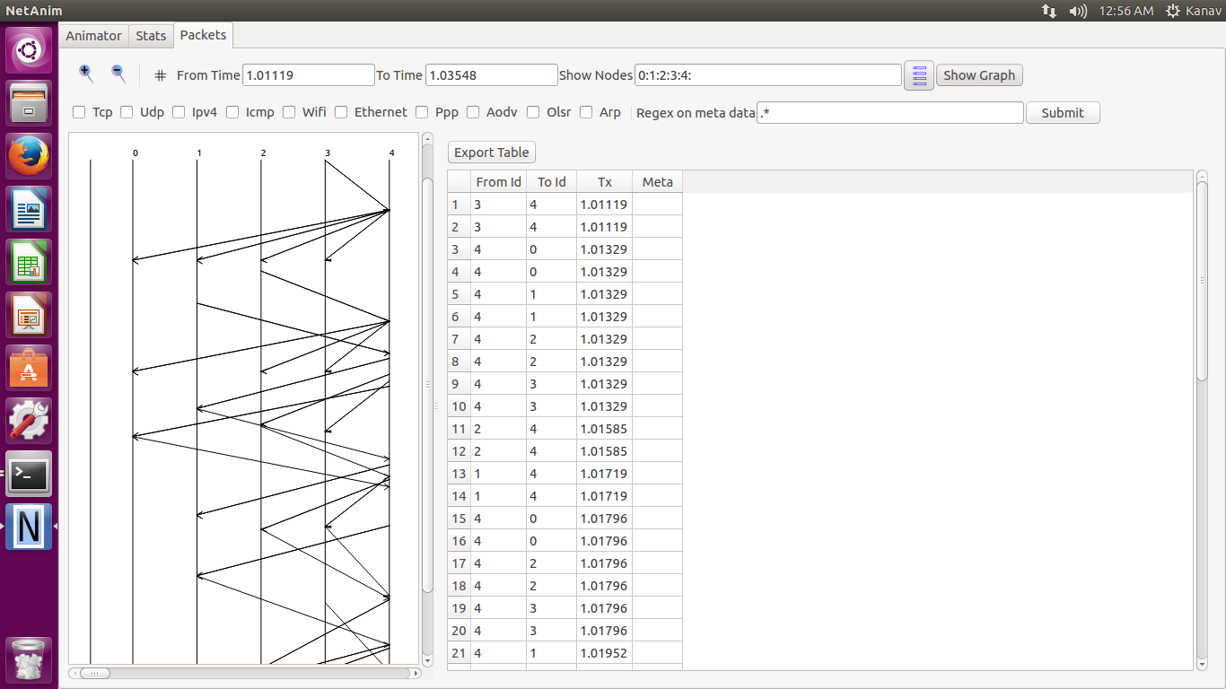

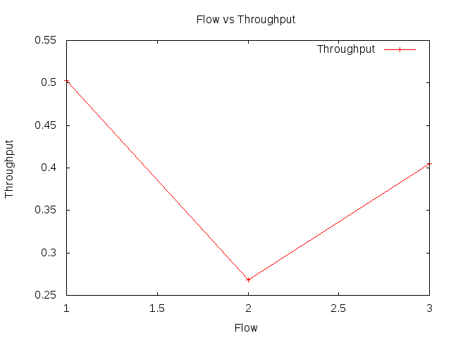

**4 to 1 Flow**

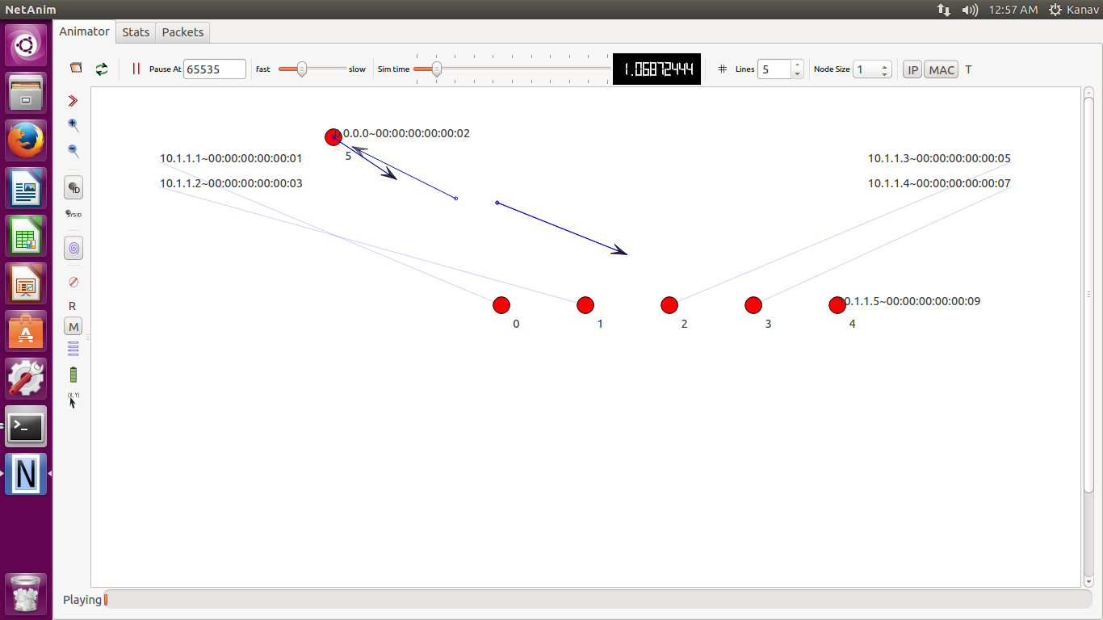

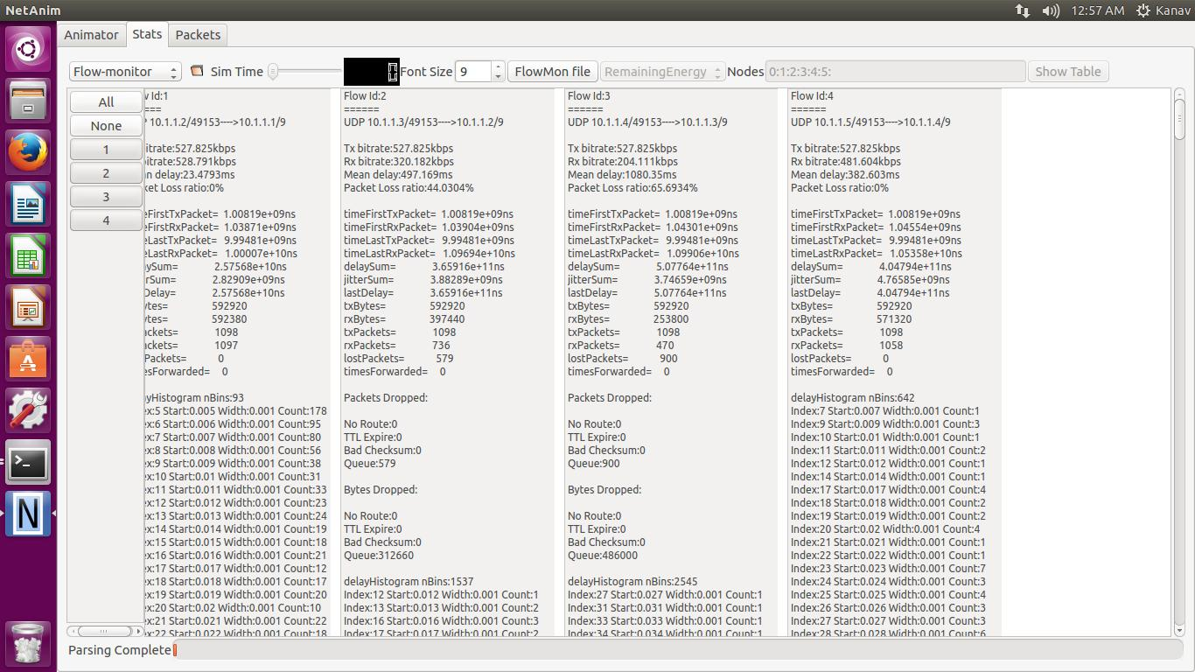

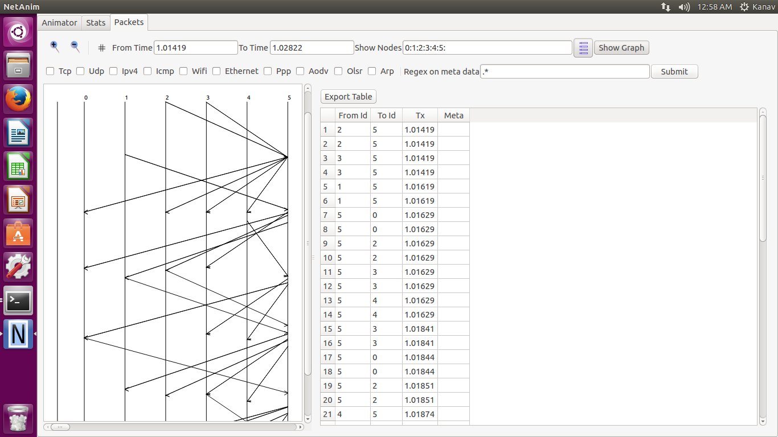

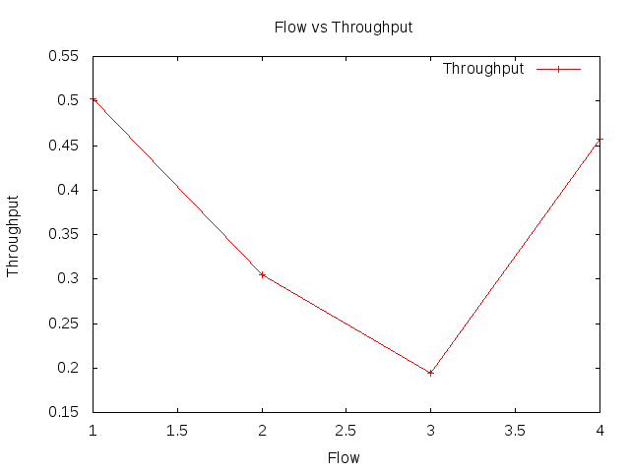

**5 to 1 Flow**

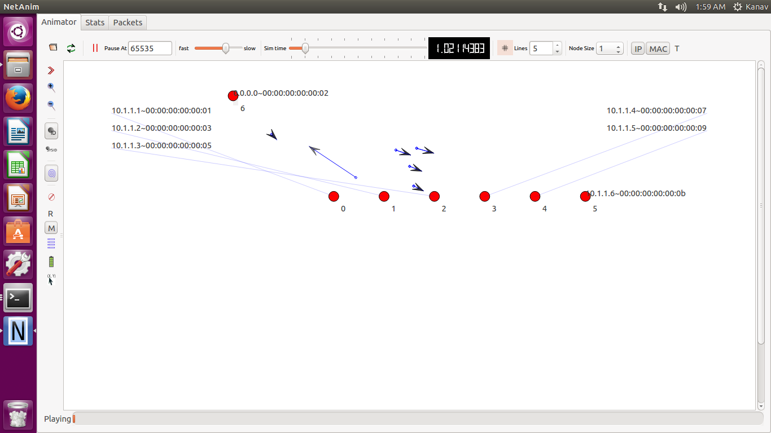

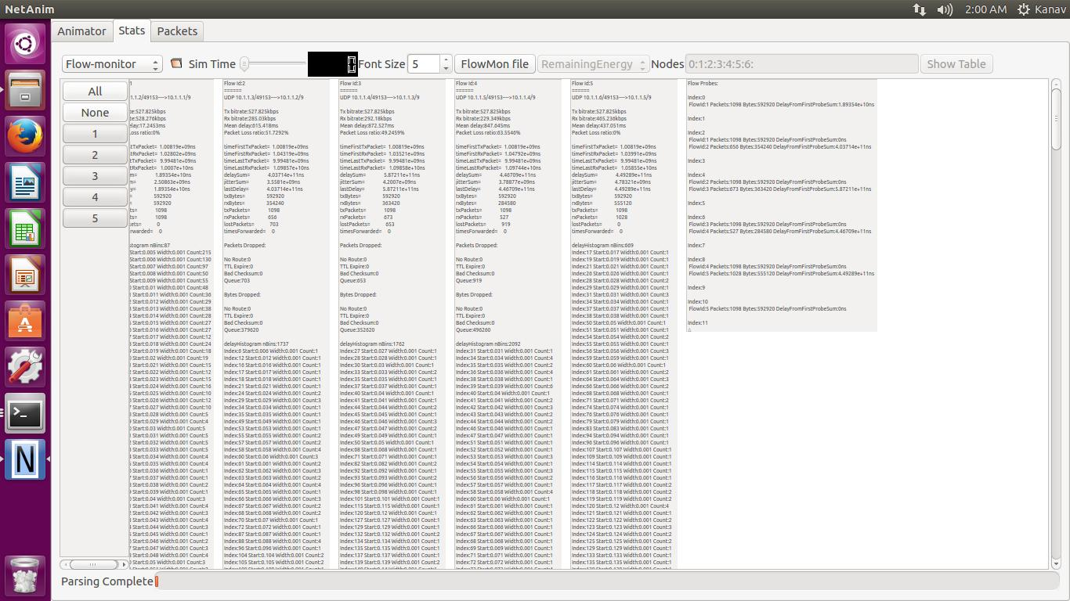

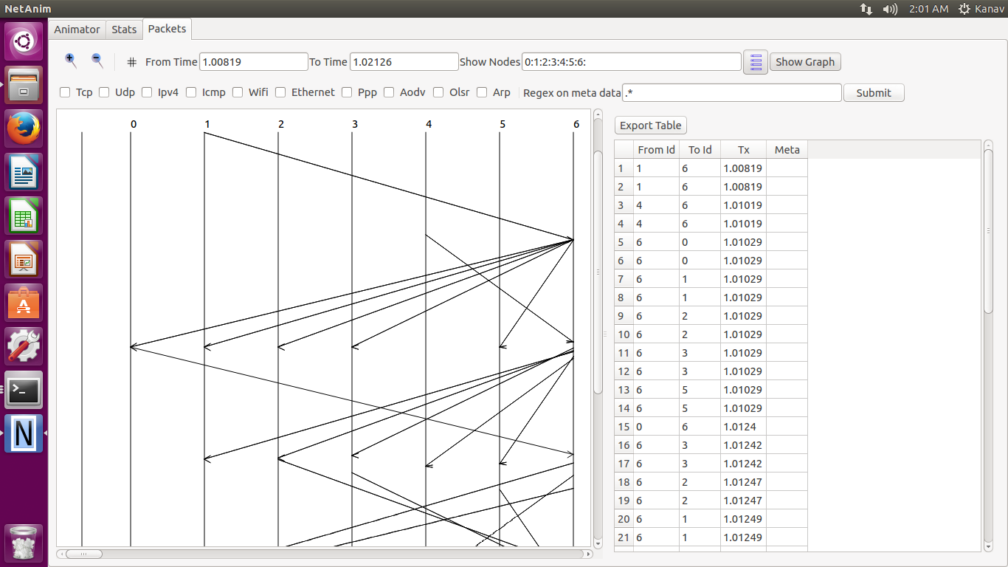

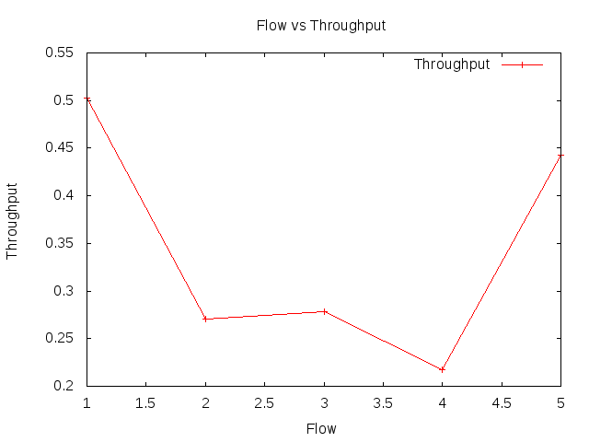

**6 to 1 Flow**

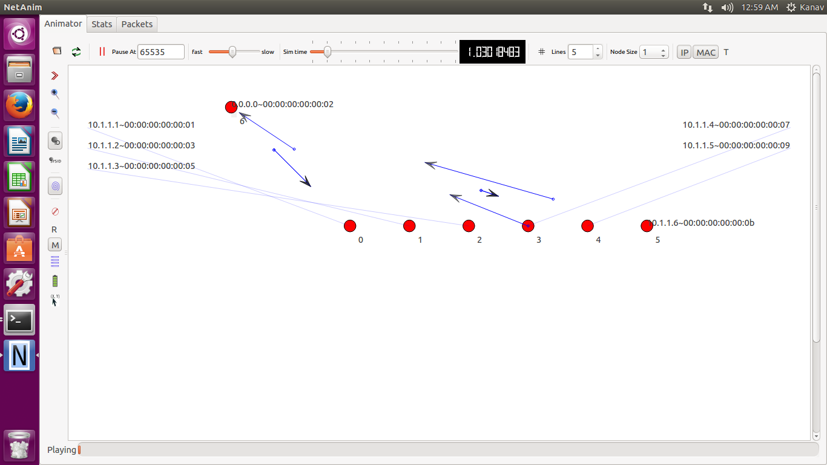

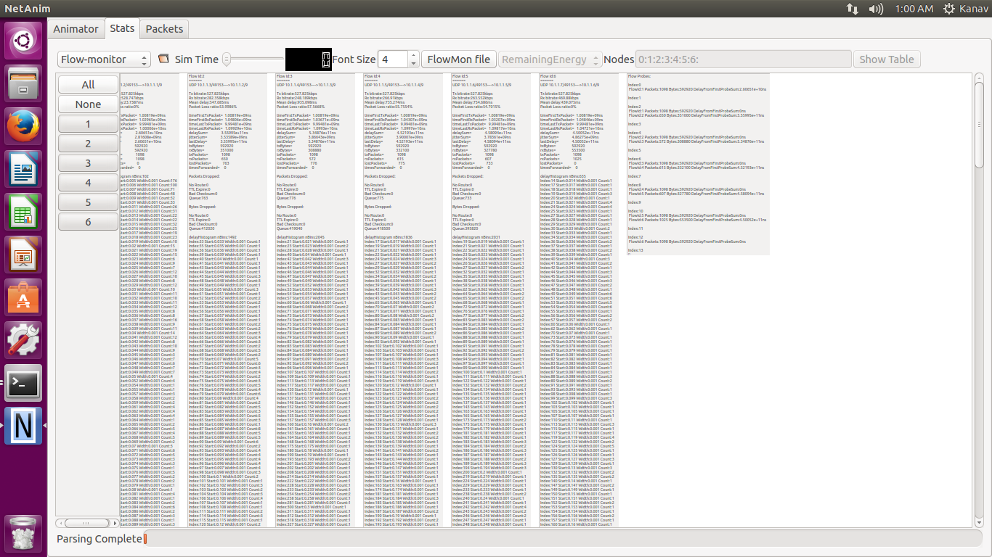

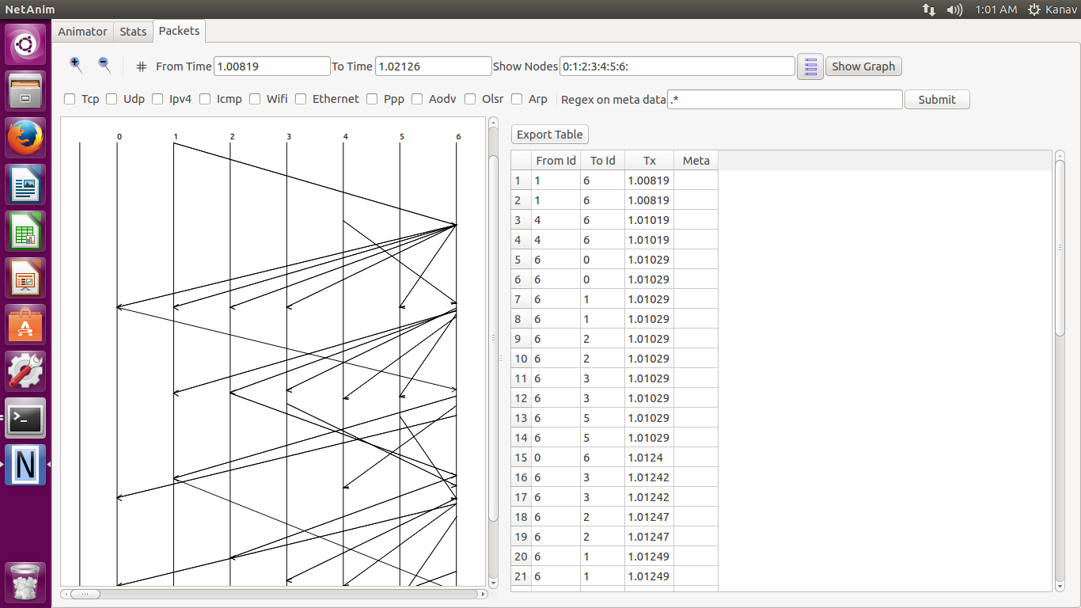

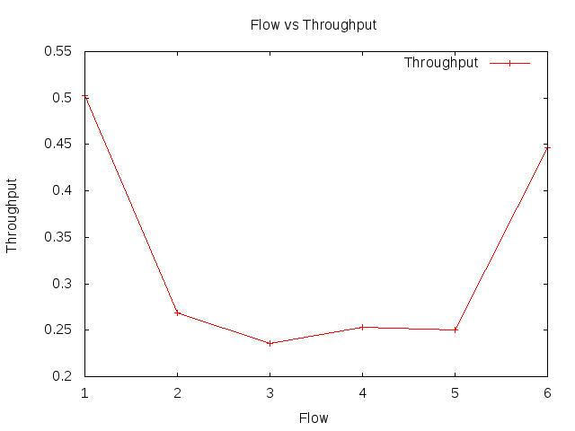

**7 to 1 Flow**

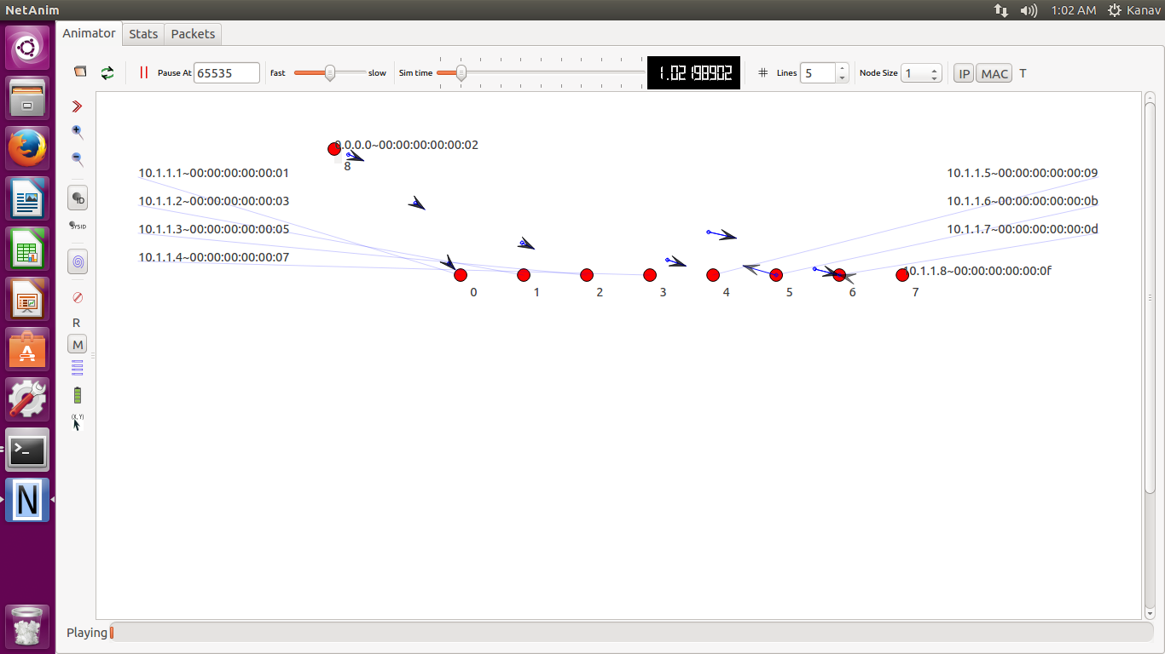

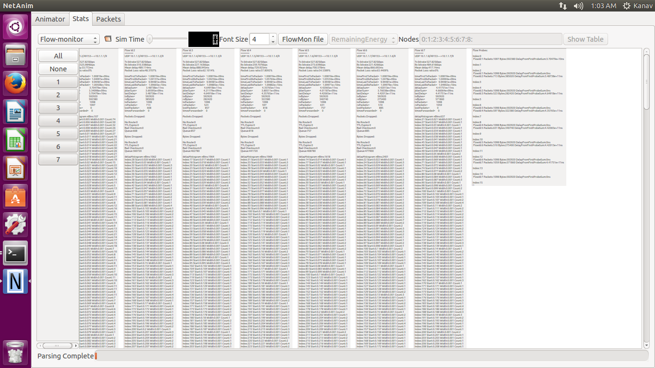

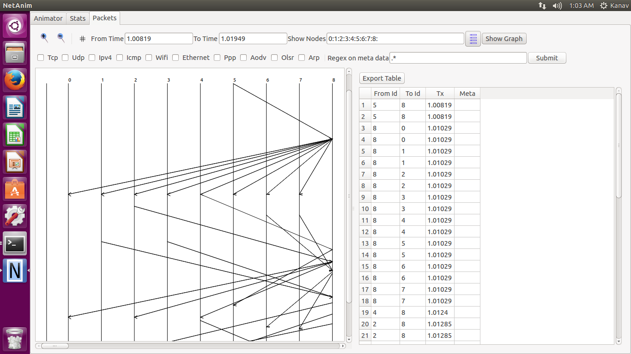

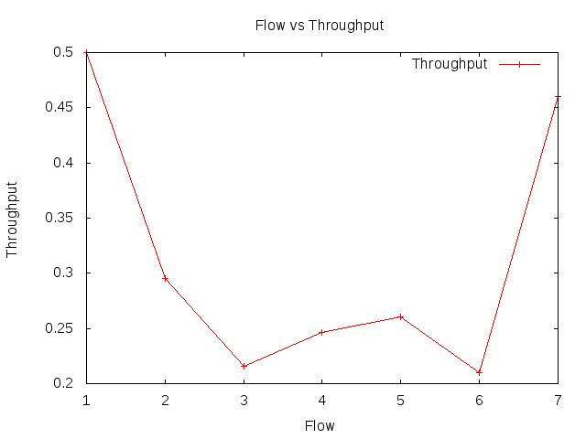

**8 to 1 Flow**

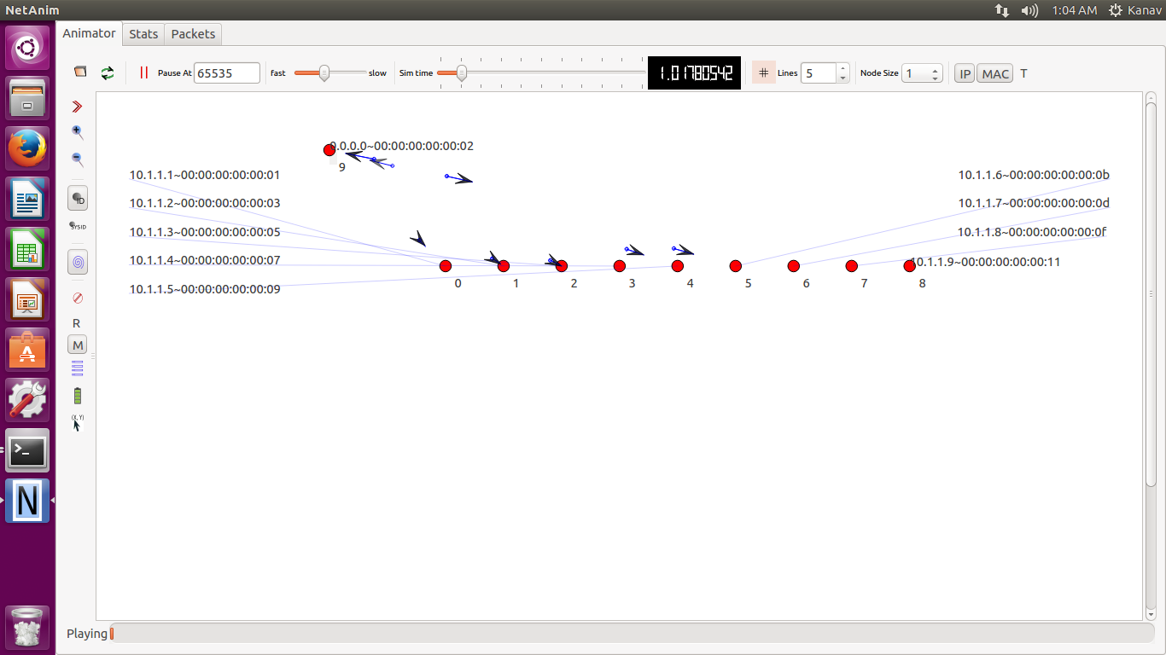

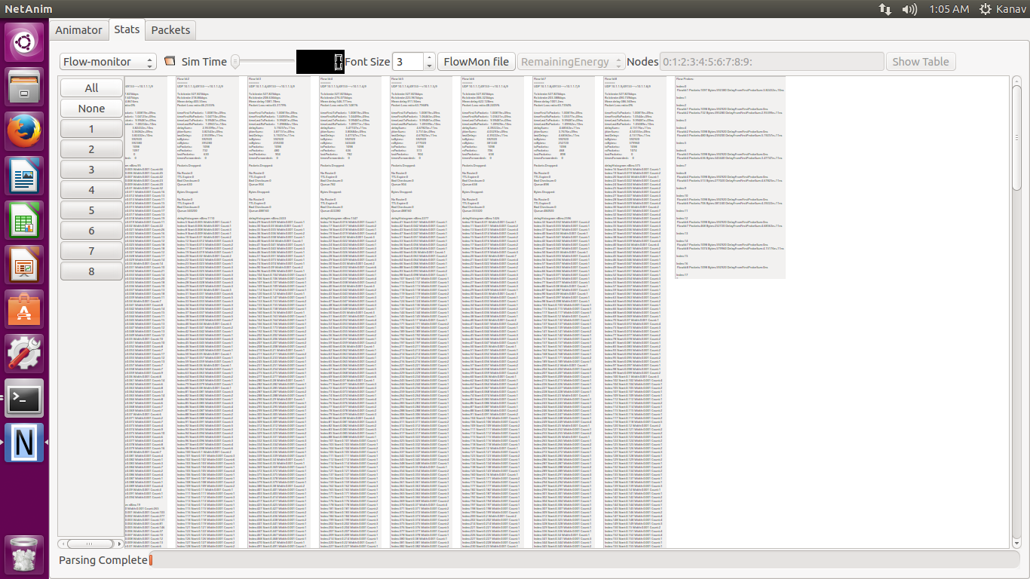

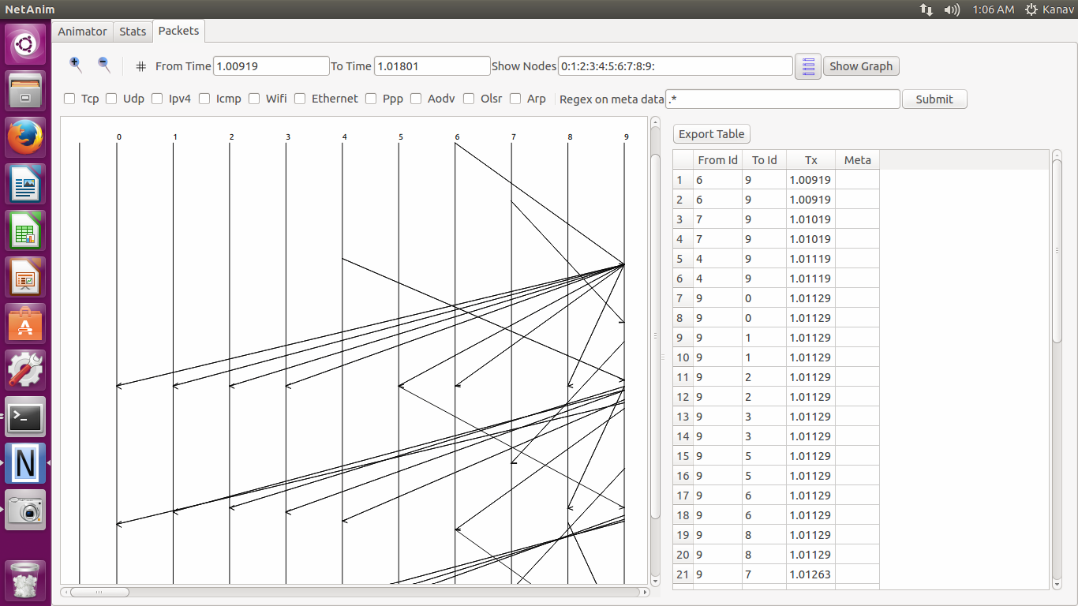

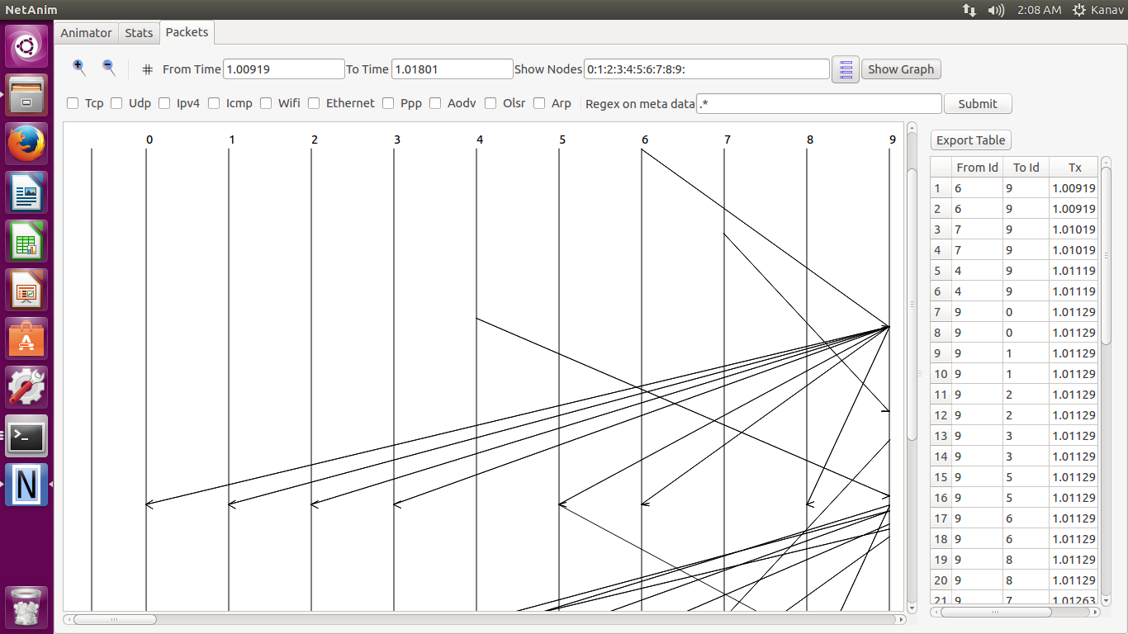

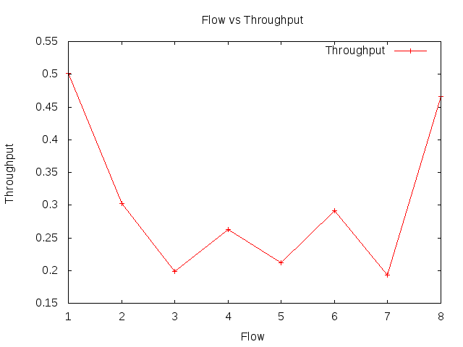

**9 to 1 Flow**

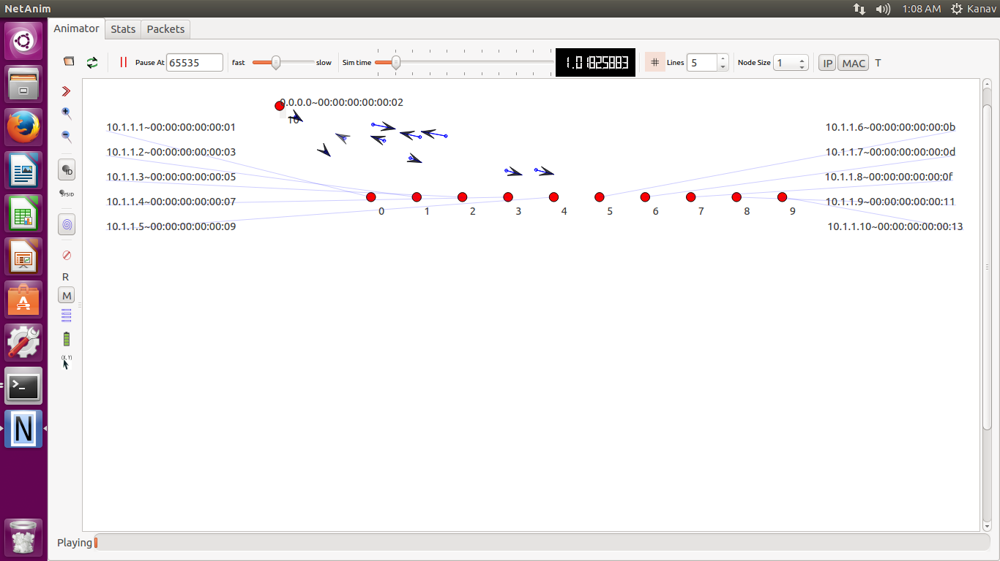

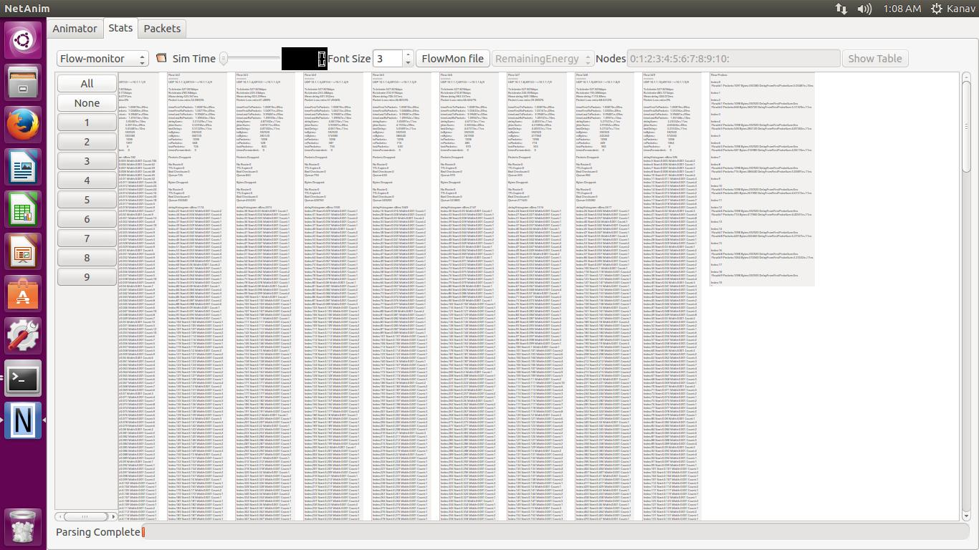

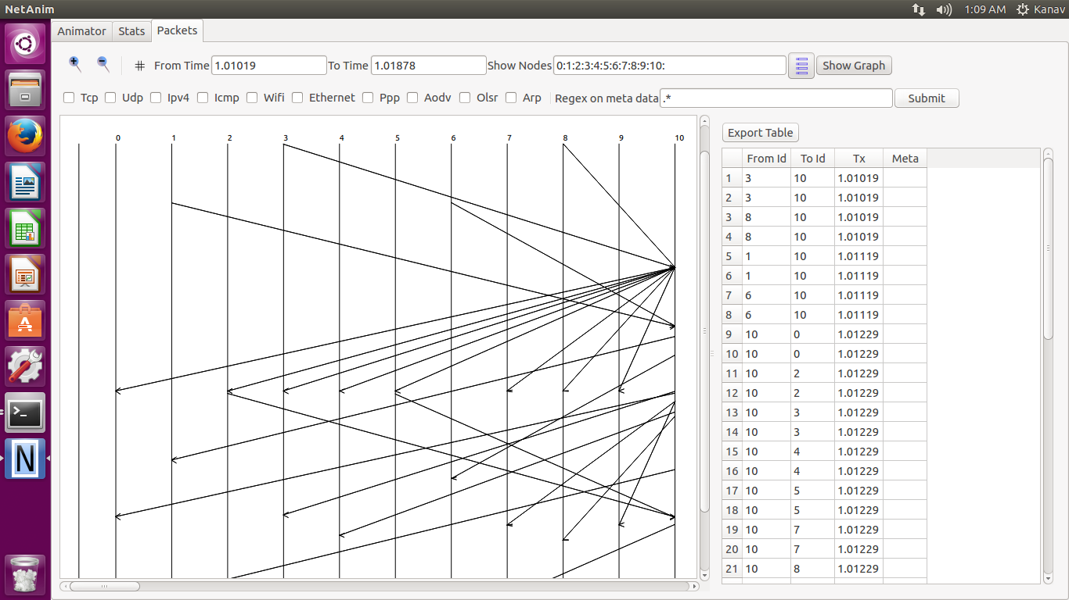

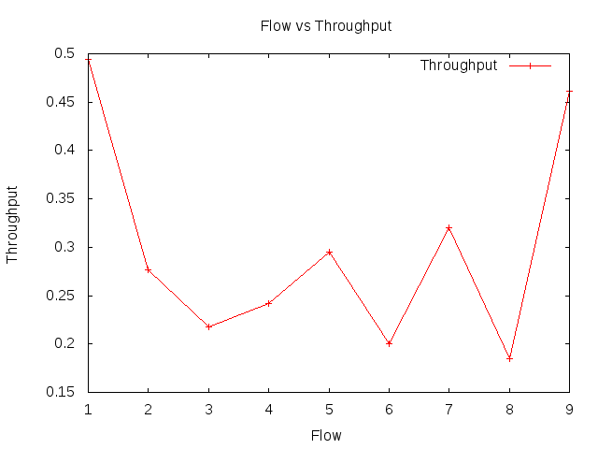

**10 to 1 Flow**

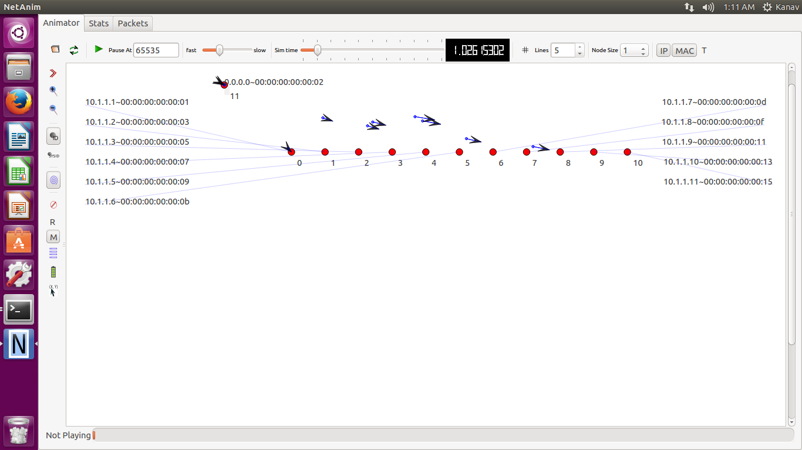

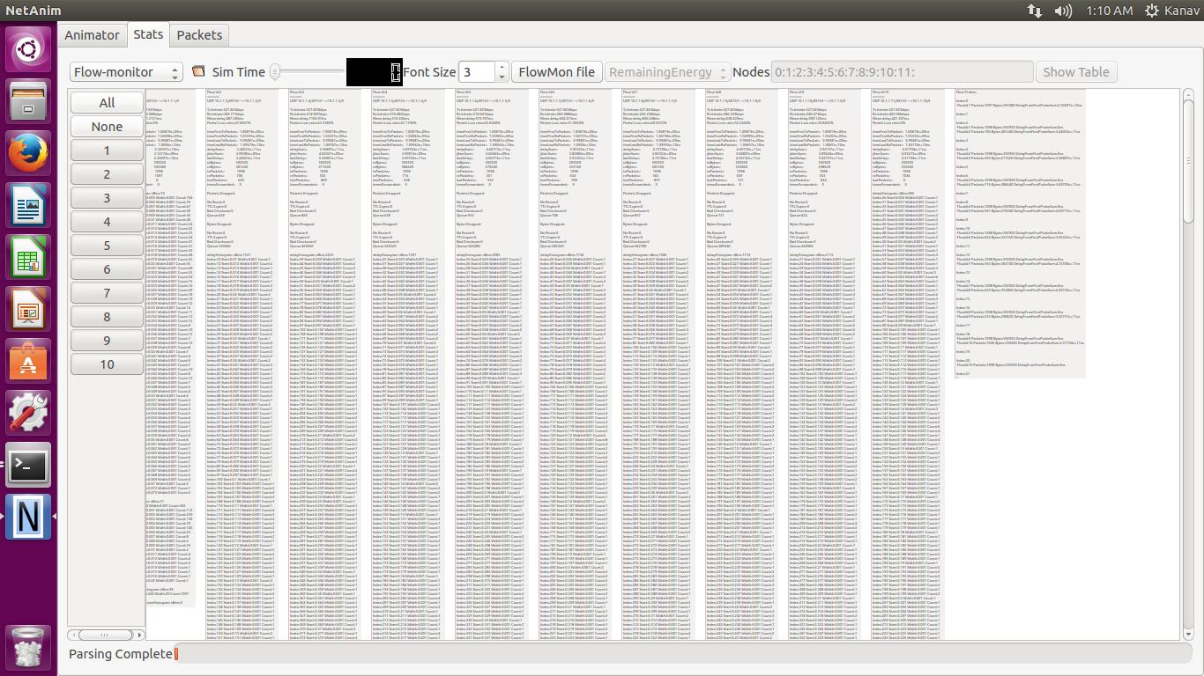

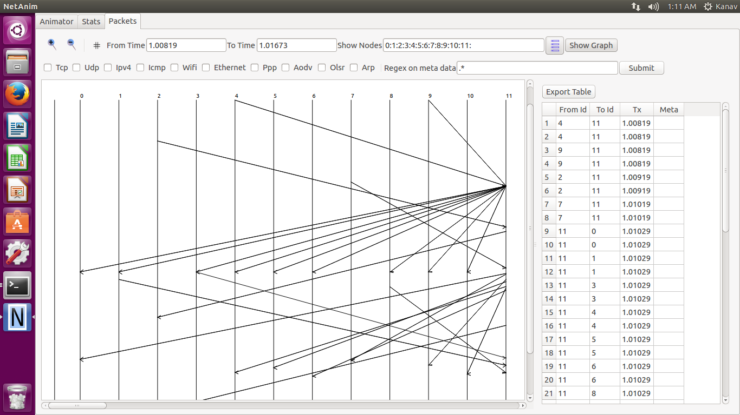

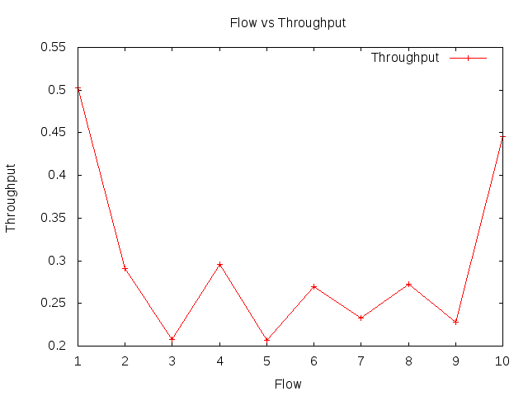

**CONCLUSION AND SCOPE OF FUTURE WORK**

As seen via the flow monitor and netanim results, at first ARP packets are sent to the controller to find paths to each node. After that, each flow has different stats, but in all the cases, Flow 1 has zero packet drop ratio. As the packet traffic increases, the drop ratio for subsequent flow’s after flow 1 increases. In almost all instances the Packet drop ratio is 50%. Also in some cases, even though all packets did not reach the destination, the number of lost packets was recorded to be zero. Further we can increase reduce the packet drop ratio via introducing TCP. Also, a better congestion control and queuing method will reduce the packet drop ratio to a great extent.

**REFERENCES**

1. P. Dely, A. Kassler and N. Bayer, "OpenFlow for Wireless Mesh Networks," 2011 Proceedings of 20th International Conference on Computer Communications and Networks (ICCCN), Maui, HI, 2011, pp. 1-6.
2. Rotsos C., Sarrar N., Uhlig S., Sherwood R., Moore A.W. (2012) OFLOPS: An Open Framework for OpenFlow Switch Evaluation. In: Taft N., Ricciato F. (eds) Passive and Active Measurement. PAM 2012. Lecture Notes in Computer Science, vol 7192. Springer, Berlin, Heidelberg.
3. Chi-Yao Hong , Srikanth Kandula , Ratul Mahajan , Ming Zhang , Vijay Gill , Mohan Nanduri , Roger Wattenhofer, Achieving high utilization with software-driven WAN, Proceedings of the ACM SIGCOMM 2013 conference on SIGCOMM, August 12-16, 2013, Hong Kong, China.